USER INFORMATION  Name: ____________________________________________  Email: ____________________________________________  Phone: ______________ Unit/Company: ________________ | BICYCLE INFORMATION  Make/Model: _______________________________________  Color: _____________________________________________  Other Information: __________________________________
How often do you ride? Commute or travel: 2+ times a week [ ] Recreational: a few times a month [ ] Seldom [ ]
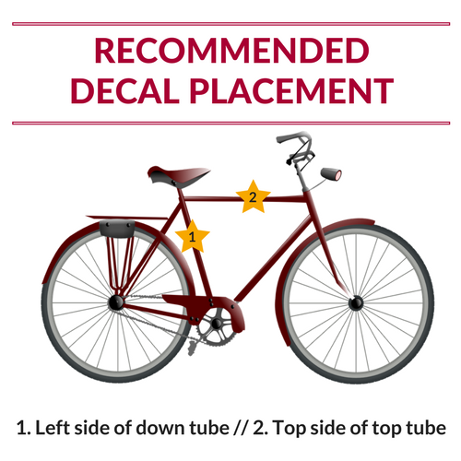
BIKE RULES & REGULATIONS
To keep everyone’s bikes safe, we restrict the use of the bike room to building users. If you are planning to store your bike, it must be registered with Arlington County and must display the Arlington County decal issued. Bikes without decals are subject to removal and donation. Arlington Transportation Partners and BikeArlington are great resources for biking in the area.
BIKE ROOM STORAGE RULES
- All bikes in the storage area must belong to someone with a valid lease.
- All bikes must be stored in racks and may not be left against walls, doors, in aisles or block access to another Users’ bike. No bikes are permitted to be chained to the front or rear fencing of the bike room.
- All bikes must display an Arlington County Decal. Please register your bike with Arlington County by visiting https://police.arlingtonva.us/bicycle-registration-form/. After registration, you will receive a decal and instructions on where to affix the decal to your bike. For questions and
follow up, please contact Lieutenant Heather Hurlock at 703.228.4057.
AGREEMENT
I, _____________________________, do hereby acknowledge that I have read and understand the rules and regulations listed above associated with receiving an Arlington County permit decal. I understand that [Building Name] is granting me permission to keep the bicycle described above in the bike room. I understand that this permission is subject to the above outlined rules and regulations. I understand that [Building Name] will not be held responsible or liable for any bicycle that is damaged and/or stolen while stored at [Building Name].

User Signature: ______________________________________________________________ Date: _________________________

